**How To Train an Object Detection Classifier for Multiple Objects Using TensorFlow (GPU) on Windows 10**

Github link:

<https://github.com/EdjeElectronics/TensorFlow-Object-Detection-API-Tutorial-Train-Multiple-Objects-Windows-10>

YouTube link:

<https://www.youtube.com/watch?v=Rgpfk6eYxJA&ab_channel=EdjeElectronics>

NOTES:

Steps:

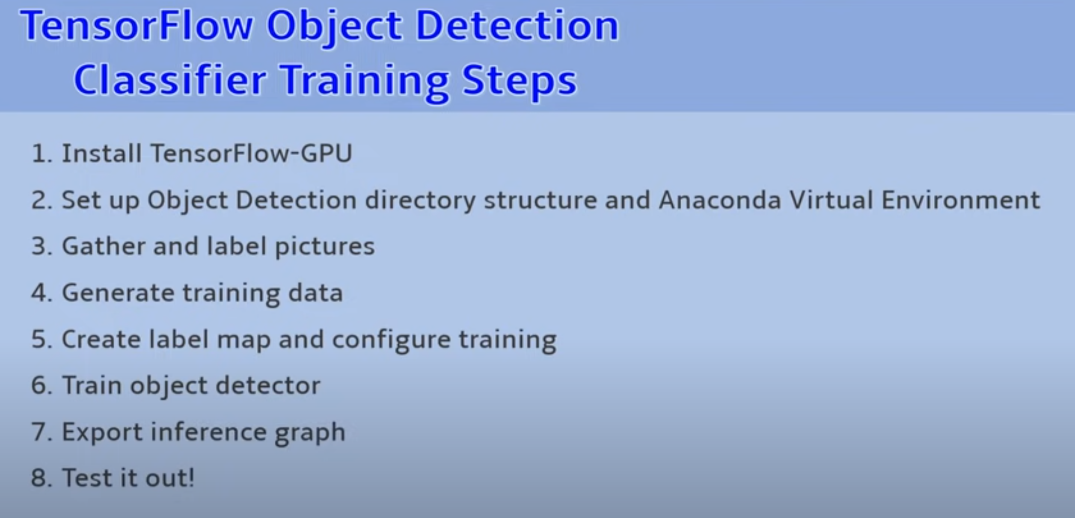

Requirements:

Tensorflow object detection API

This program works on windows 10 ( will also run on win 7,8, linux)

1.Watch Mark Jay how to install TF-GPU 1.4 video before installation of tf-gpu

Link: <https://www.youtube.com/watch?v=RplXYjxgZbw&ab_channel=MarkJay>

2.However, install 1.5 instead of 1.4 , and instead of cuda 8+ cudnn 6 shown in the above video link install cuda 9 and cudnn 7 along with tensorflow 1.5

(The latest version available for this project is with tensorflow 1.13, accordingly other versions also change )

3.Install python 3.6 after installation of anaconda virtual environment

[www.anaconda.com/download](http://www.anaconda.com/download)

4.Install the dependencies required : link as per the video

[www.github.com/tensorflow/models/blob/research/object_detection/g3doc/installation.md](http://www.github.com/tensorflow/models/blob/research/object_detection/g3doc/installation.md)

dependencies

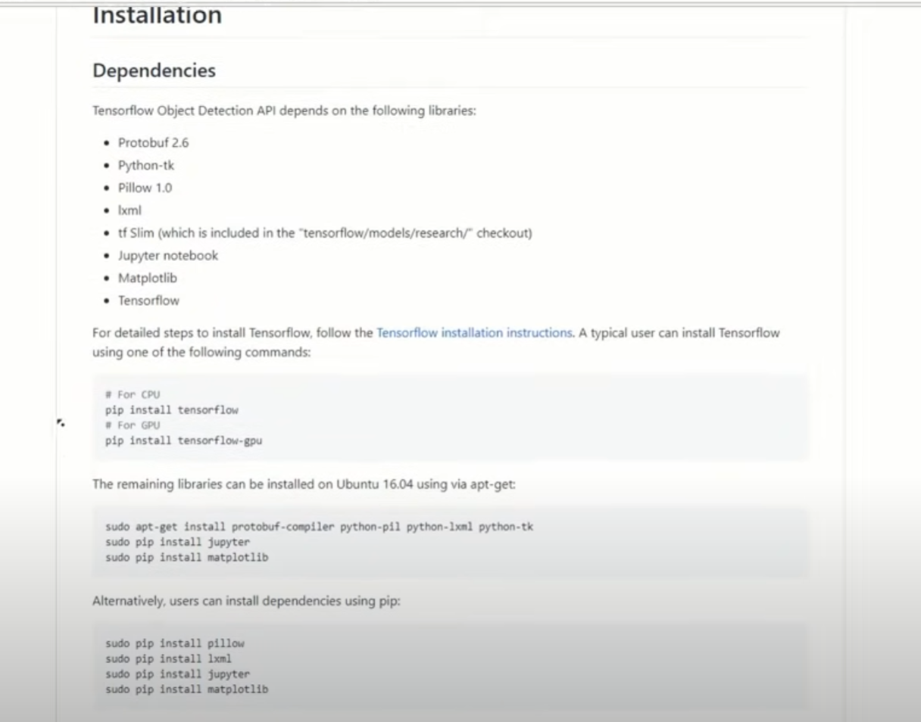

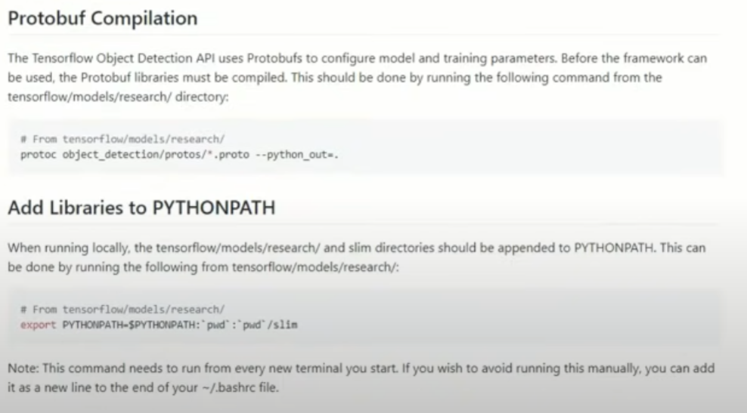

Working Link: <https://github.com/tensorflow/models/blob/master/research/deeplab/g3doc/installation.md>

5. create a folder directly in c and name it tensorflow1 , download tensorflow repository from the link: <https://github.com/tensorflow/models>’

6. extract the folder models-master from the zip file and paste it in the tensorflow1 folder and rename it to models

7. go to the tensorflow zoo model using the link: <https://github.com/tensorflow/models/blob/master/research/object_detection/g3doc/tf1_detection_zoo.md>

You find a lot more models with different speed. For a device with low computational power such as a smartphone or a raspberry pi use the ssd mobile net model . for a decently powered desktop or laptop go ahead with one of the faster rcnn models , here we are using faster_rcnn_inception_v2.coco model

8. Download faster_rcnn_inception_v2.coco model

9. Extract the content in this model and paste it in tensorflow1->models->research->object_detection

10. Go to the github link of the repository given in the first line above (<https://github.com/EdjeElectronics/TensorFlow-Object-Detection-API-Tutorial-Train-Multiple-Objects-Windows-10>) Here we have different python files such as tf record generator.py and object detection using webcam.py. Go to images and annotations folder

11. Download the repository , extract the contents and save them in this path tensorflow1->models->research->object_detection

12. Before starting your own training, do the following things:

I.go to the training folder inside the above mentioned path and delete labelmap and config file

II.go to the inference graph and delete the placeholder file

III.go to the images folder and delete the test labels.csv and train labels.csv files

IV. for testing the existing model, you can leave all the images and xml files in test and train folders inside images folder

13. For creating your own object detector , delete all of the files in the train and test folders , replace them with new ones (images) to start from scratch.

14. By now, the project directory should look like this:

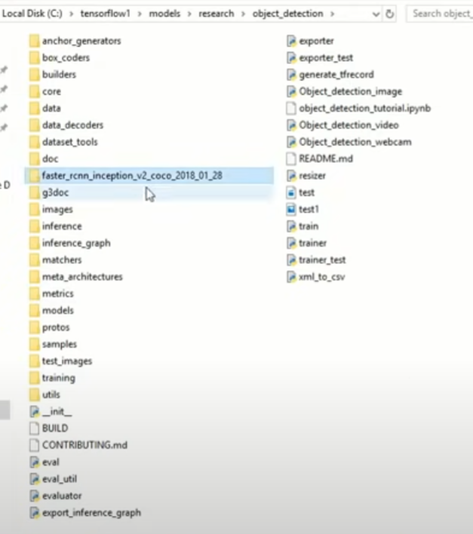

15. Now setup virtual environment in anaconda prompt- follow the commands shown in section 2d:

<https://github.com/EdjeElectronics/TensorFlow-Object-Detection-API-Tutorial-Train-Multiple-Objects-Windows-10#2d-set-up-new-anaconda-virtual-environment>

16.run anaconda as admistrator and type the command in the terminal:

Conda create -n tensorflow1 pip (or conda create –name env_name python==3.6)

activate tensorflow1

pip install --ignore installed –upgrade tensorflow-gpu==1.5.0

conda install –c anaconda protobuf

pip install pillow

pip install lxml

pip install jupyter

pip install matplotlib

pip install pandas

pip install opencv-python

add folders to path

set PYTHONPATH=C:\tensorflow1\models\;C:\tensorflow1\models\research;C:\tensorflow1\models\research\slim

set PATH=%PATH%;PYTHONPATH

echo %PATH%

echo %PYTHONPATH%

repeat these steps if you close anaconda prompt

cd C:\tensorflow1\models\research

copy command from this link:

<https://github.com/EdjeElectronics/TensorFlow-Object-Detection-API-Tutorial-Train-Multiple-Objects-Windows-10#2f-compile-protobufs-and-run-setuppy>

protoc --python_out=. .\object_detection\protos\anchor_generator.proto .\object_detection\protos\argmax_matcher.proto .\object_detection\protos\bipartite_matcher.proto .\object_detection\protos\box_coder.proto .\object_detection\protos\box_predictor.proto .\object_detection\protos\eval.proto .\object_detection\protos\faster_rcnn.proto .\object_detection\protos\faster_rcnn_box_coder.proto .\object_detection\protos\grid_anchor_generator.proto .\object_detection\protos\hyperparams.proto .\object_detection\protos\image_resizer.proto .\object_detection\protos\input_reader.proto .\object_detection\protos\losses.proto .\object_detection\protos\matcher.proto .\object_detection\protos\mean_stddev_box_coder.proto .\object_detection\protos\model.proto .\object_detection\protos\optimizer.proto .\object_detection\protos\pipeline.proto .\object_detection\protos\post_processing.proto .\object_detection\protos\preprocessor.proto .\object_detection\protos\region_similarity_calculator.proto .\object_detection\protos\square_box_coder.proto .\object_detection\protos\ssd.proto .\object_detection\protos\ssd_anchor_generator.proto .\object_detection\protos\string_int_label_map.proto .\object_detection\protos\train.proto .\object_detection\protos\keypoint_box_coder.proto .\object_detection\protos\multiscale_anchor_generator.proto .\object_detection\protos\graph_rewriter.proto .\object_detection\protos\calibration.proto .\object_detection\protos\flexible_grid_anchor_generator.proto

_pb2 files are created in the path

python setup.py build

python setup.py install

cd C:\tensorflow1\models\research\object_detection

jupyter notebook object_detection_tutorial.ipynb

Run each section by clicking run button at the top in the jupyter notebook opened in the browser

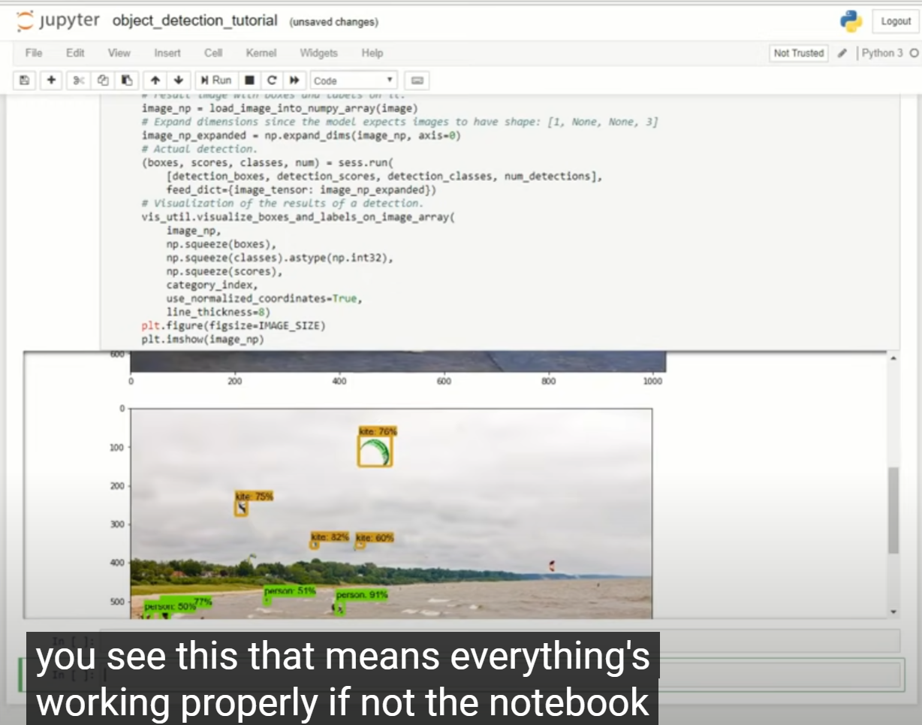

17. For common errors, refer to the appendix

18. Gather and label pictures- detection classifier needs hundreds of images of an object to train a good classifier. To train a robust classifier , the training images should have random objects in the image along with the desired objects and should have a variety of background and lighting conditions. Along with this, there should also be some images where the desired object is partially obscured, overlapped with something else or only halfway in the picture

18. Take at least 200 images and make sure that the images aren’t too large. They should be less than 200 kilobytes each and they shouldn’t have a resolution higher than 720 * 1280 pixels (the larger the images are the longer it will take to train the classifier).

19. Paste 80% of the images in object_detection->images->train folder and the rest 20% images in object_detectio->images->test folder . Make sure there are variety of pictures in both test and train directories.

20. Now you have to label the imagers. Label Img is a great open source image labelling tool . Download labelimg from github using the link: <https://github.com/tzutalin/labelImg#installation>

21. Once you have installed, run it and open the train directory

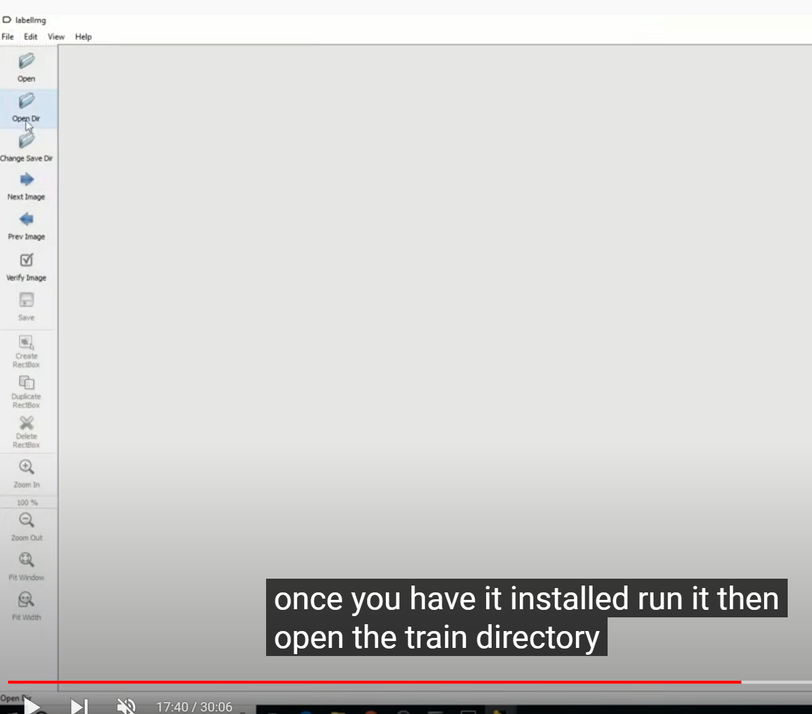

22. Click on rectangular box and draw rectangular boxes around the object in the image , type in a label for the object . Repeat this or label another object and save annotations in the form of xml file (pascal voc preferably). Move to next picture in the directory and repeat the process. This is to be done for every image in the train directory and test directory (meticulous process but we should)

23. Once the images are labelled it’s time to generate the TF records that serve as input data to the tensorflow training model. Our test and train folders should now be full of xml files . These xml files to contain the coordinates of the bounding rectangles for each object in the image. To generate the tf record we use the xml to csv and generate tf record python scripts in the command prompt.

24. Make sure you’re in the object detection folder and then enter:

python xml_to_csv.py

This creates a train labels and test labels csv file in the images directory these csv files just have the coordinates of the bounding rectangles for every object in every image.

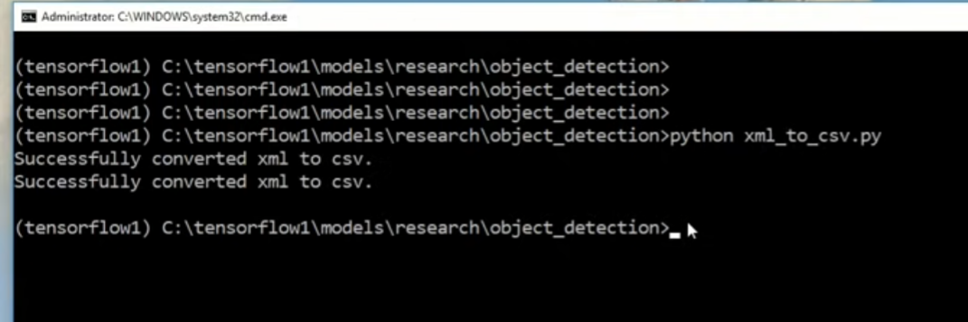

25. Open the generate tf record file with text editor, replace the label map starting at line 31 with your own label map or each object is assigned an ID number

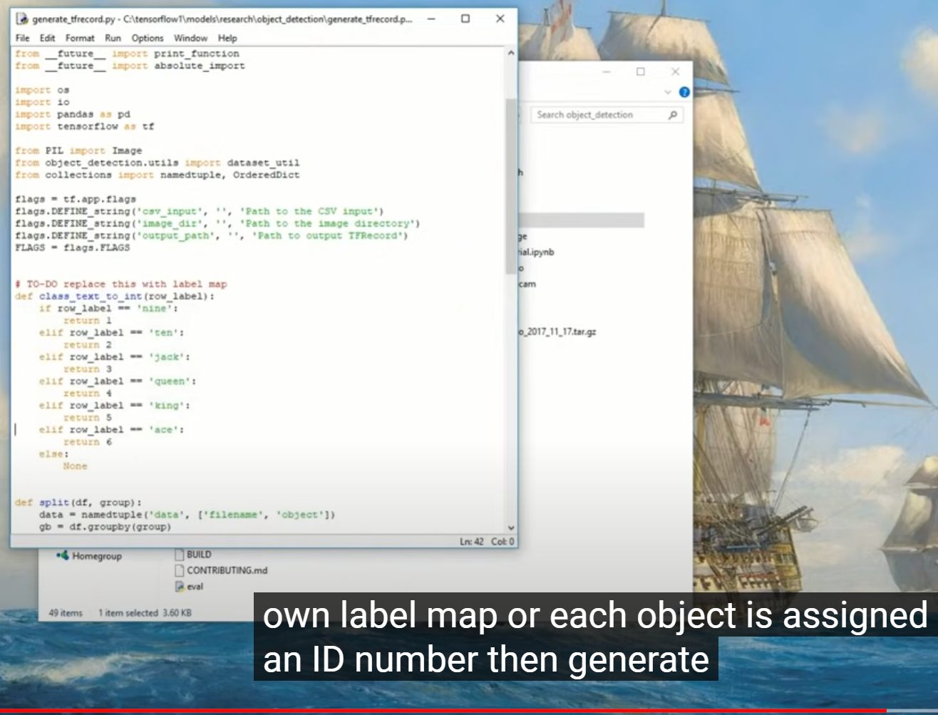

Then generate the TF records by entering the following command:

python generate_tf_record.py –csv_input=images\train_labels.csv –image_dir=images\train –output_path=train.record

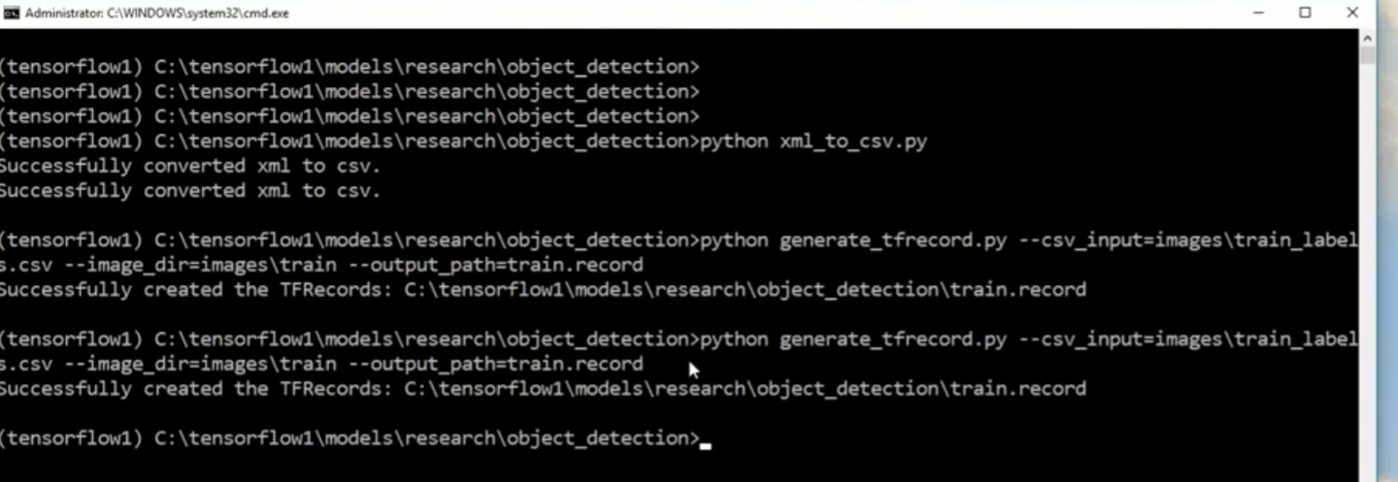

26. Then we repeat the same command except to replace every instance of train with test

python generate_tf_record.py –csv_input=images\test_labels.csv –image_dir=images\test –output_path=train.record

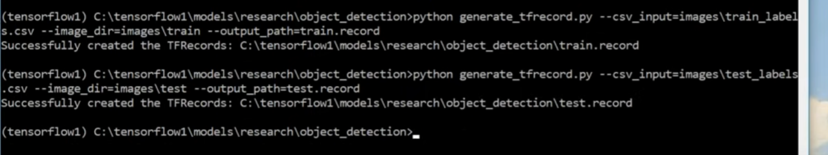

27. The above commands create train.record and test.record which are used to train the needed classifier.

**STEP 5: Create label map and configure training**

28. We need to create a label map for a classifier and then edit the training configuration file.

We’ll start with the label map which tells the trainer what each object is by defining a mapping of class names to class ID numbers. For example,

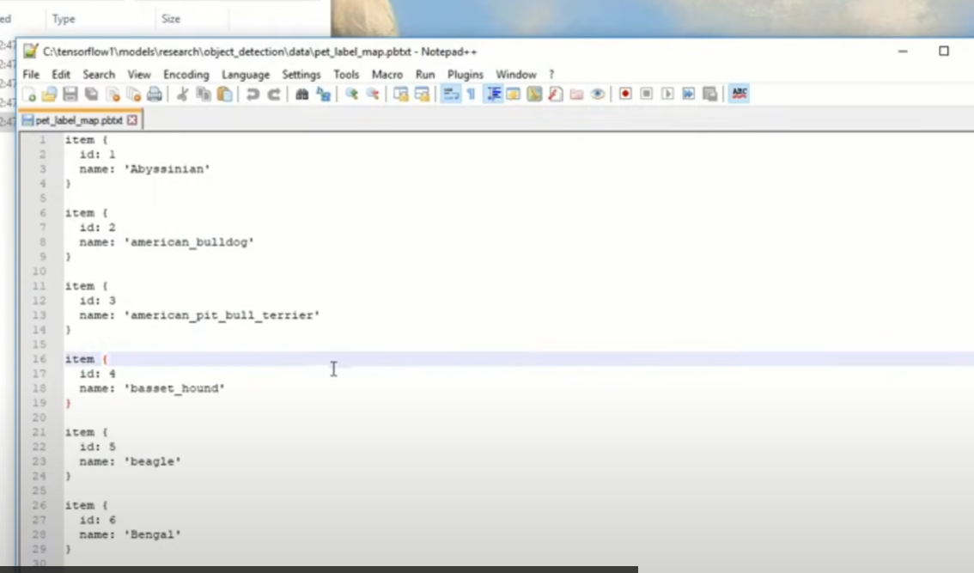

You can see the label map in the data directory in the pet label map file. Use a text editor to create a new file and save it as labelmap.pbtxt and save it in training directory.

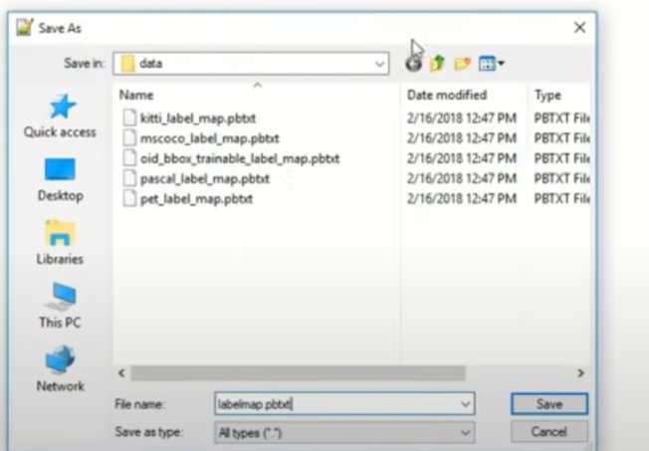

Then type your label map in it is the same format as the pet label map file. Follow this:

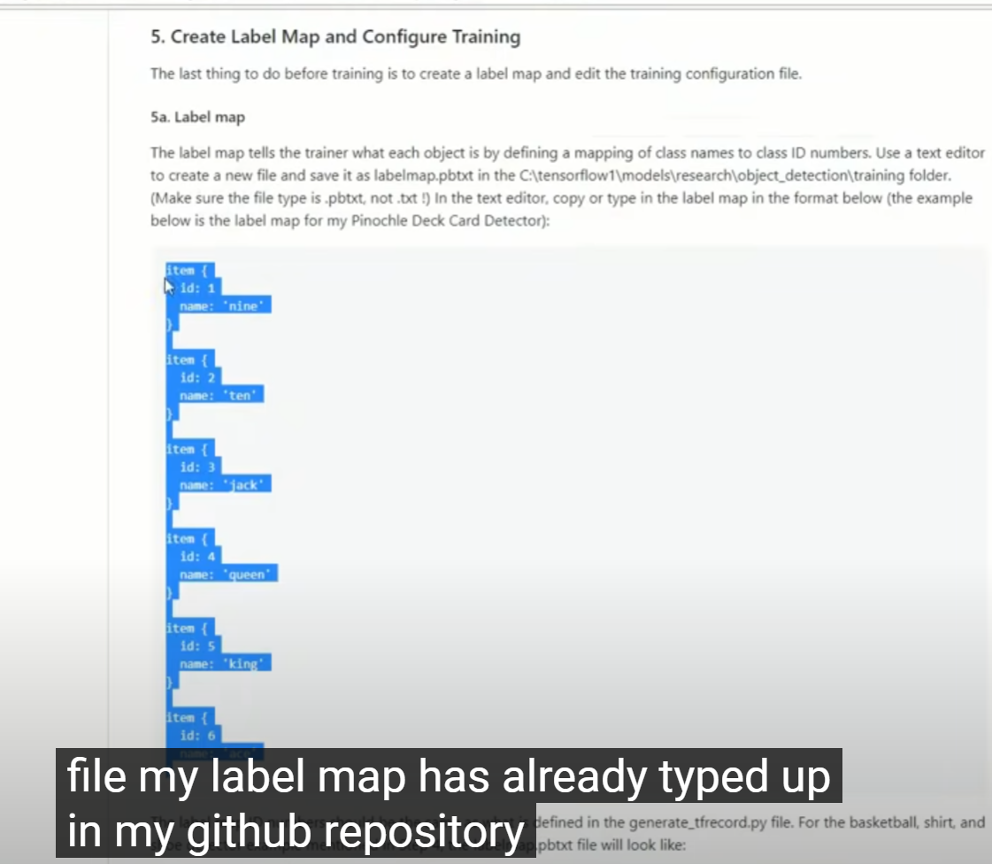

Save the file after pasting

29. Now we need to configure the object detection training pipeline. It defines which models and what parameters will be used for training and points through the training images and data and the object detection folder navigate to the samples and config folder and copy the faster rcnn in section-5 pets config file and paste in the training folder.

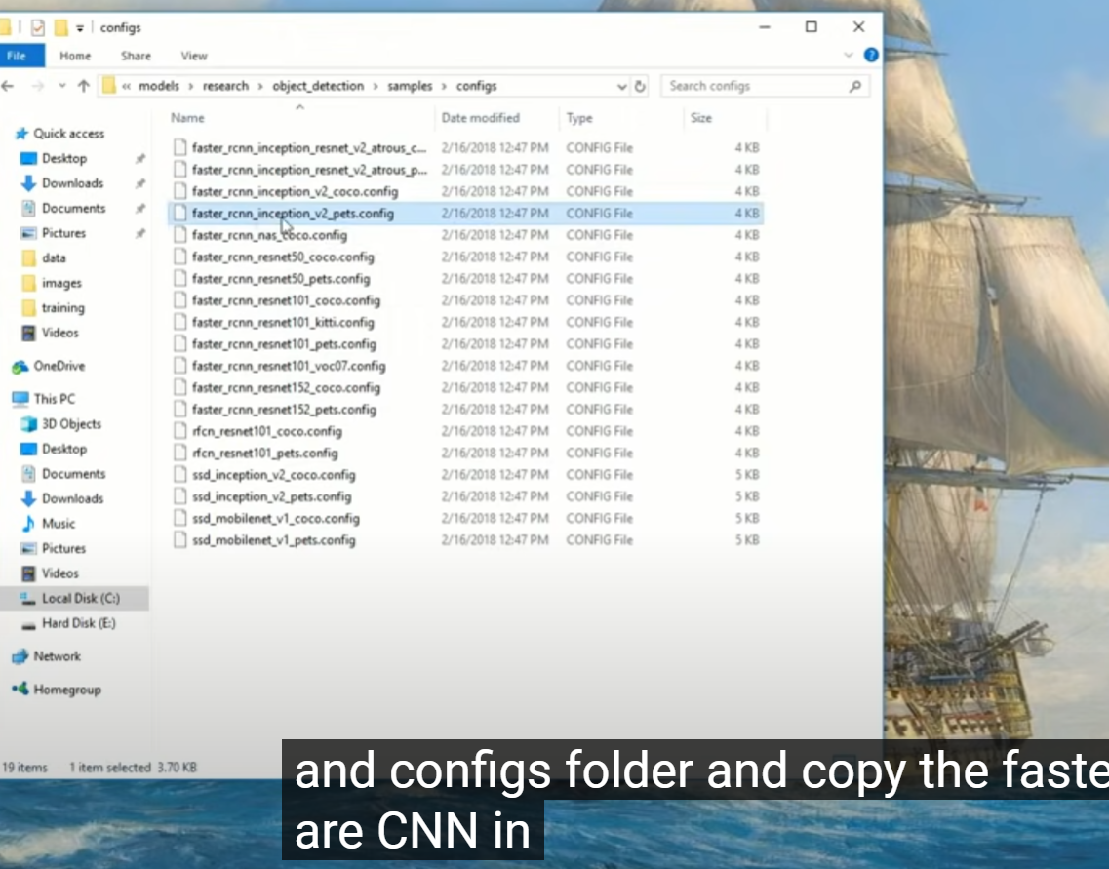

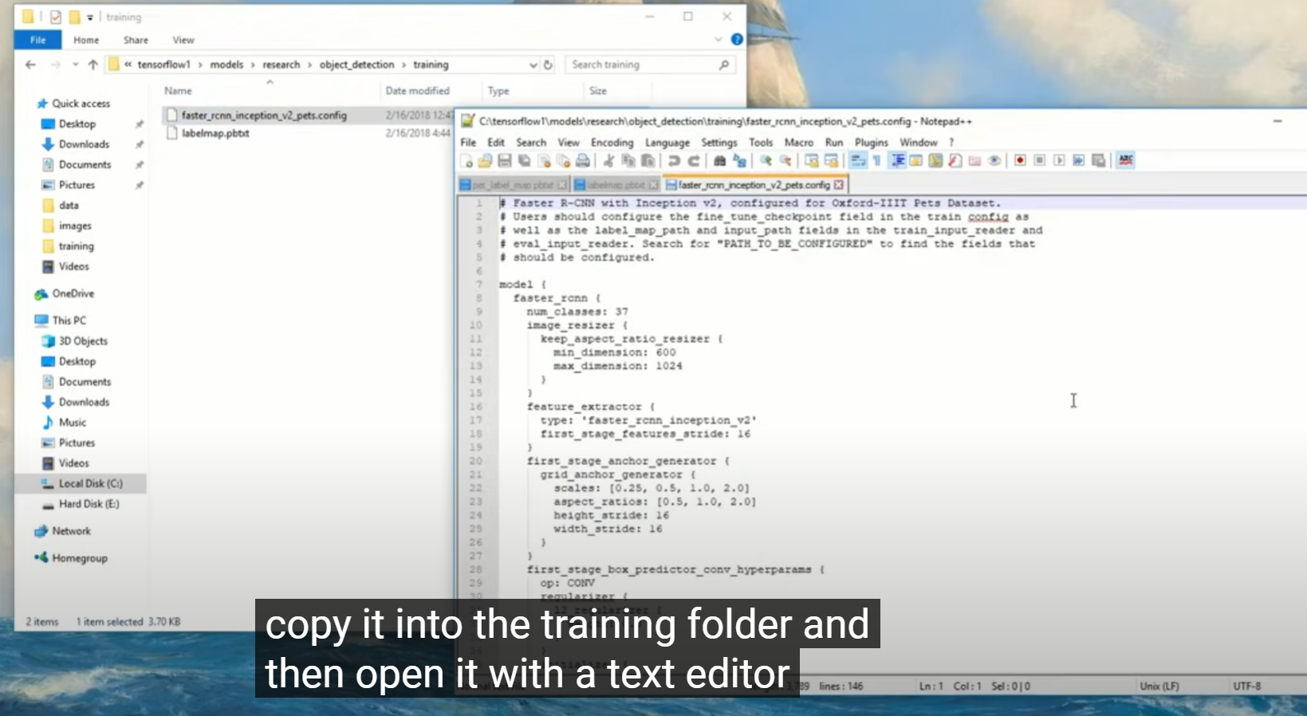

30. Open this copied file with a text editor. Several changes are to be made mainly changing the number of classed and examples and adding the file paths to the training data. First change the num variable to the number of classes you want to detect.

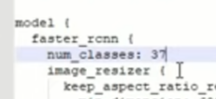

Then change the finetune checkpoint variable to point at the faster rcnn inception model file. Make sure to use forward slashes else it won’t work.

Copy the path from github link: 

And paste it here:

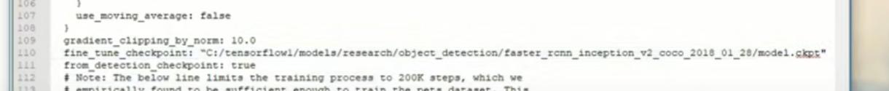

Similarly change the input path to add the train.record and the label map path to point at the label map file again

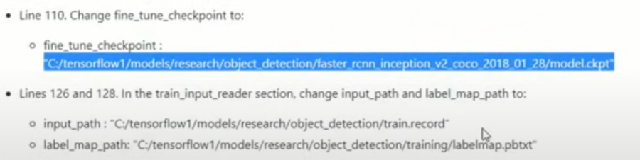

Copy from github link as shown and paste it as shown below:

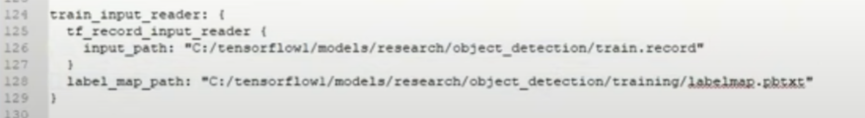

Change the number of examples in eval config to the number of test images you are using.

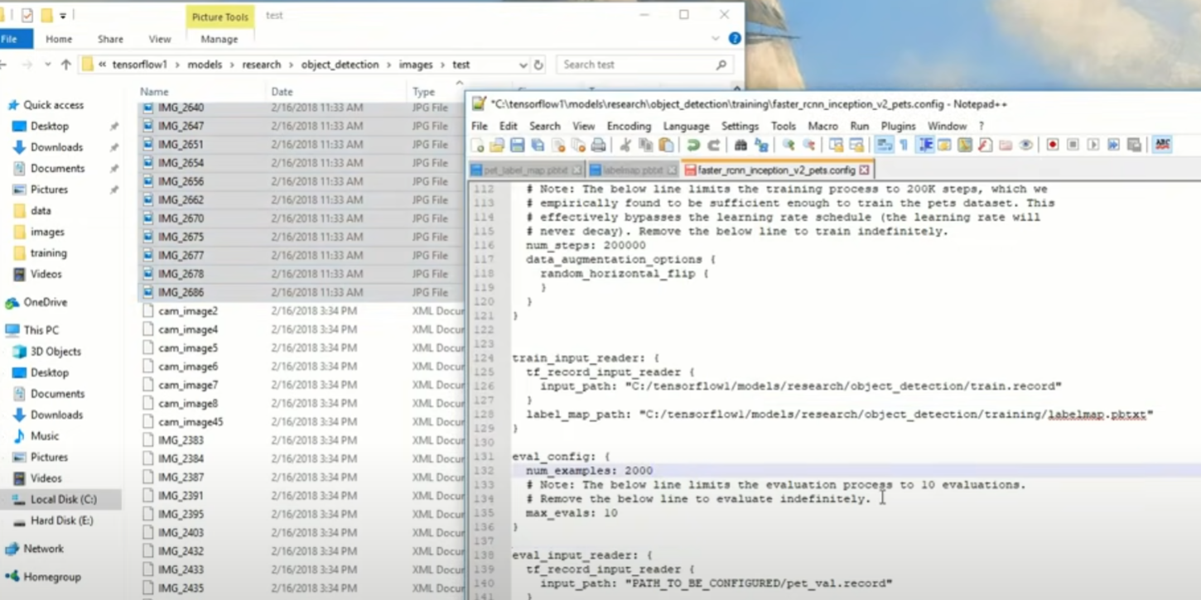

In the eval input reader, change the input path and label map path . Copy from github link as shown:

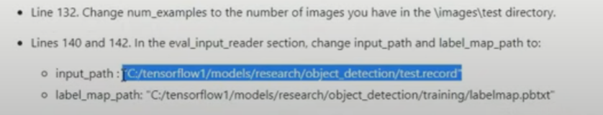

And paste it as shown below:

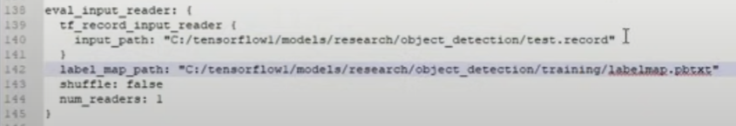

Make sure you put forward slashes(back slashes throw an error). Now save the file in the path mentioned:



**STEP 6: Train Object detector**

31.Make sure you are in object detection folder. Then type :

python train.py –logtostderr –train_dir=training/ --pipeline_config_path=training/faster_rcnn_inception_v2_pets.config

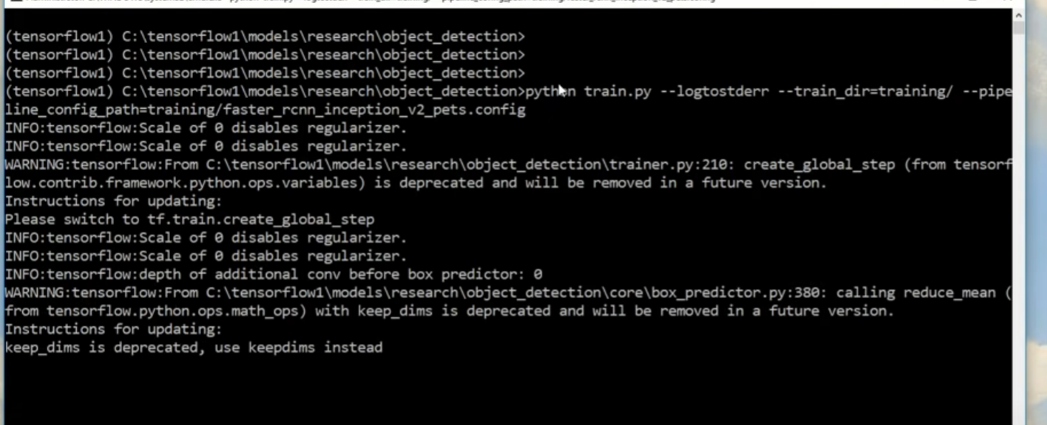

The training begins , it will start stepping through training batches and reporting the loss at each step the loss starts high and gets lower as the object detection classifier trains .While training 100% of cpu or gpu is used, therefore it is recommended not to do anything on your computer. Training requires lots of processing power so keep the classifier unitl the loss is consistently below 0.05.

32. Open new instance of anaconda prompt running it in administrator mode. Activate tensorflow1 environment

Then type cd path of object_detection as shown below:

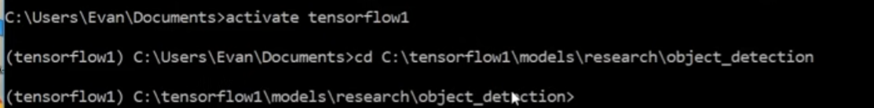

Open tensorboard to visualize the training as shown below:

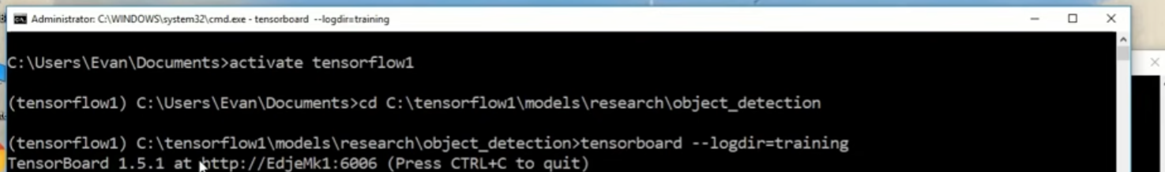

Copy the address and paste it into your web browser. It shows the tensorboard as shown below.

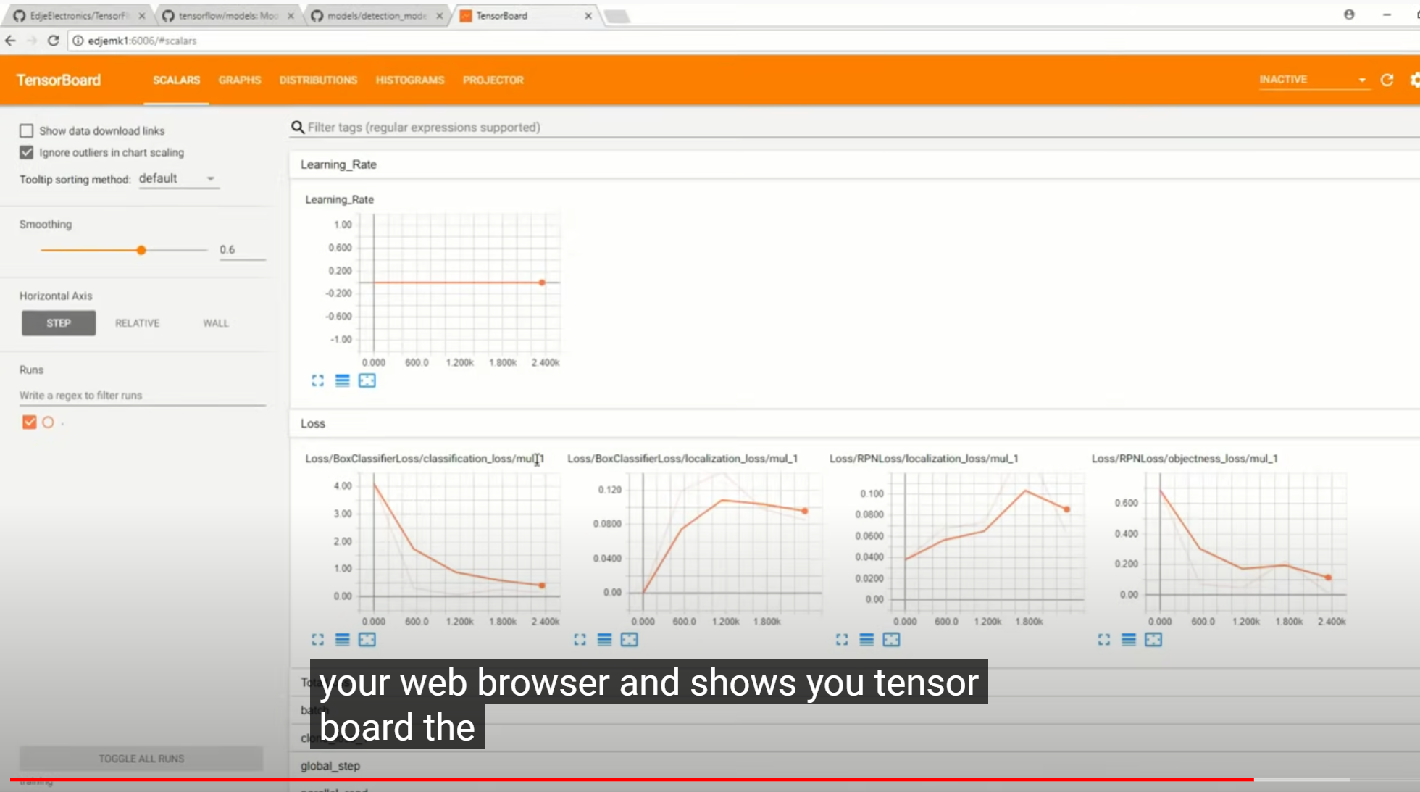

Important graph is the loss graph which shows the overall loss of the classifier. The loss graph starts after a couple of minutes after the training is started. We allow the training to run until the loss drops below 0.05 nearly (till 0.2 in video)

Approx. 3 hours later(depends on input size)

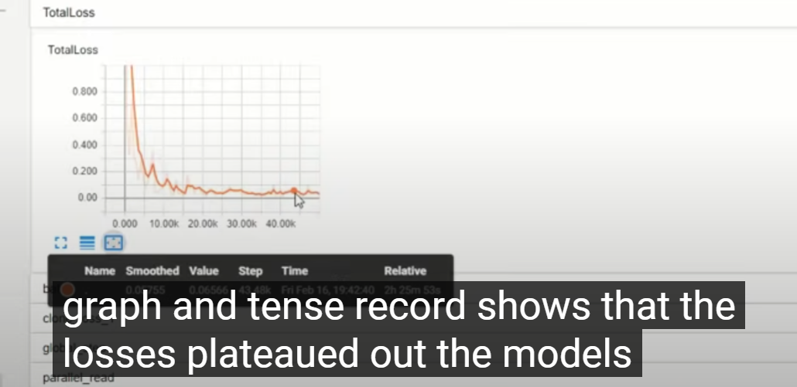

Now we can see in the graph as well as on the terminal that the loss is consistently below 0.5 , so terminate the training by pressing ctrl+c in the command prompt

It saves checkpoints every five minutes or so and stores them in the training folder .

The checkpoint of highest step count will be used to generate the classifier

The training is complete.

STEP7 : Export inference graph

The last step is to generate the frozen inference graph. Make a note of the step count of the highest model checkpoint in the training folder.

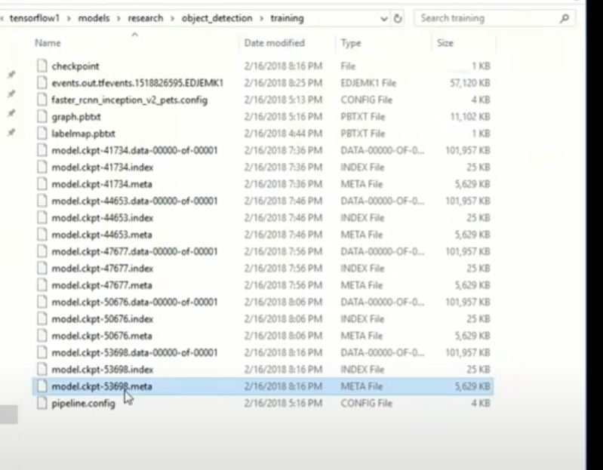

33. Go to the command prompt and make sure you are in the object detection directory paste the export inference graph command from step 7 in the github link:

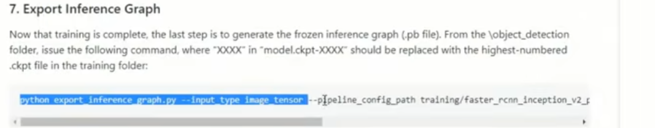

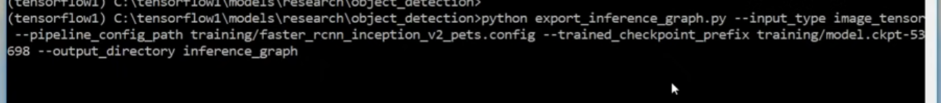

This creates a frozen inference graph.pb file in the inference graph folder in the object detection directory. The .pb file contains the object detection classifier.

STEP 8:

Now you can test your object detector on image, video or webcam feed

Type idle in the command prompt to open the python shell.



Open the object detection webcam python script

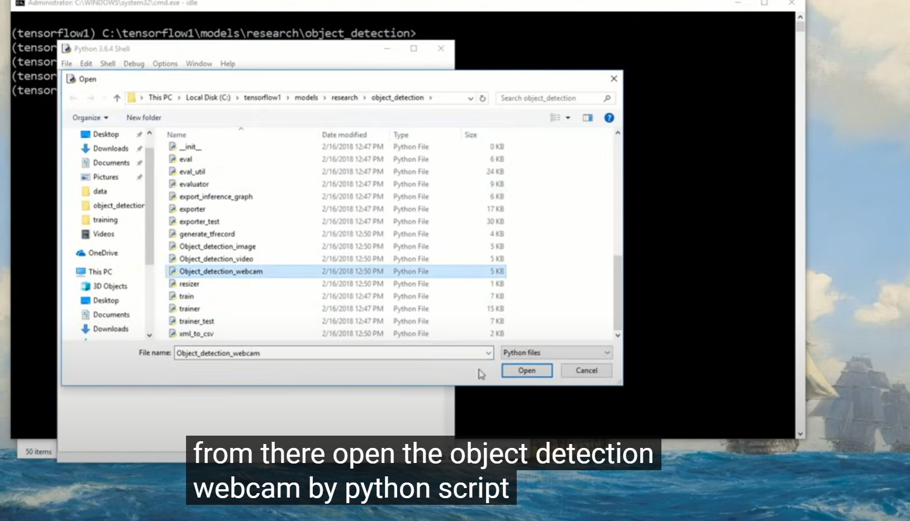

Before running the script modify the num classes variable to equal to no of objects you want to detect

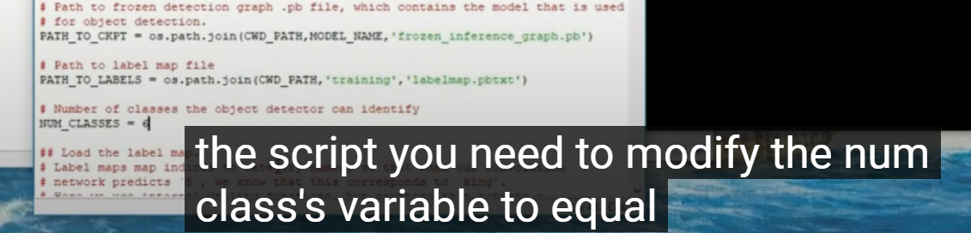

Now run the script . If everything works fine the object detector will initialize for about ten seconds and display a window showing the webcam feed with the desired objects identified.

Sample output:

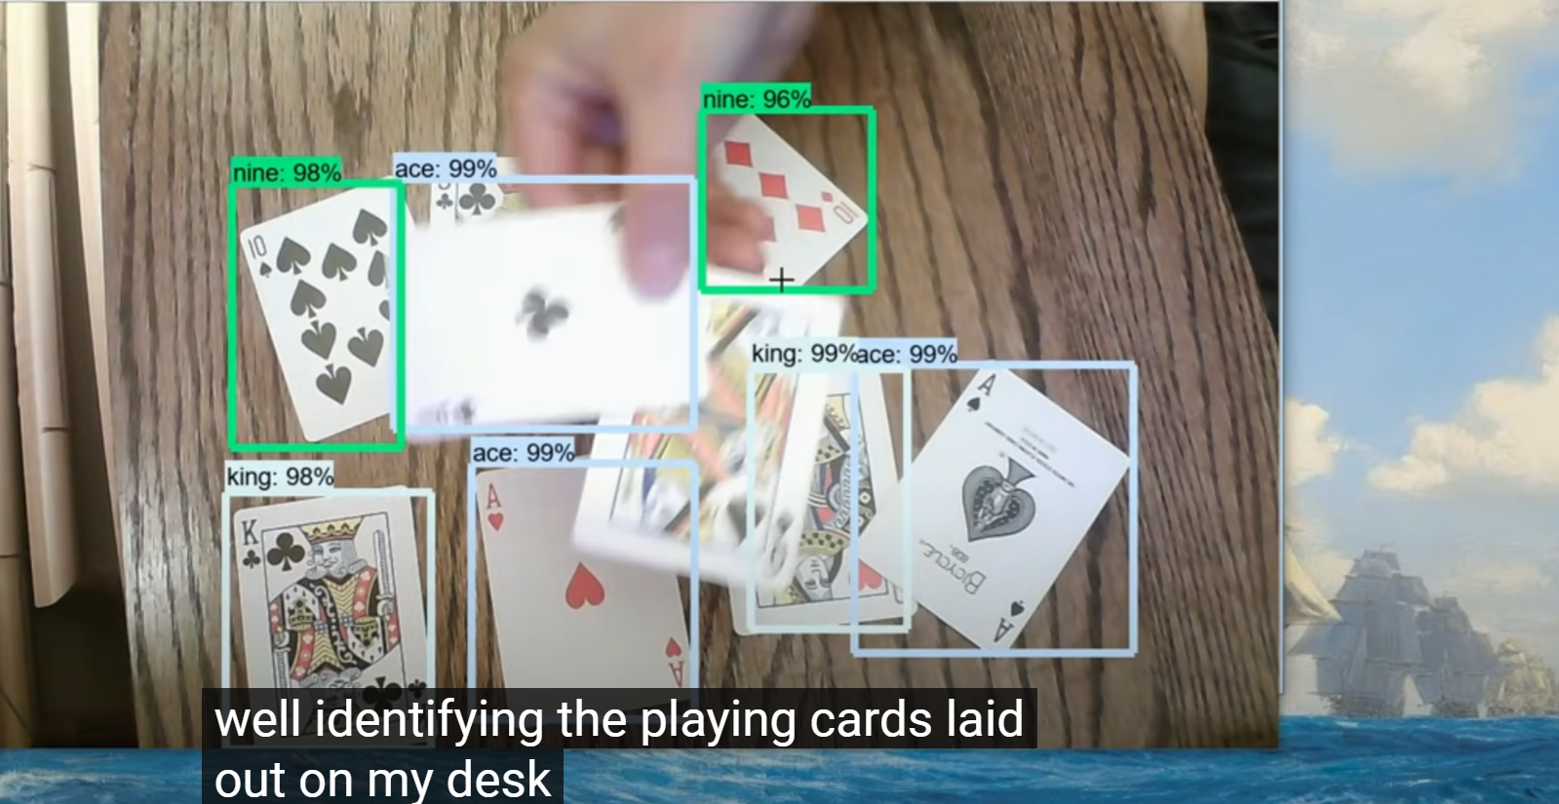

We can quit the webcam window by pressing ‘q’ on keyboard.

You can also test images and videos in a similar fashion by using object detection images and object detection video python scripts. Just change the variable num classes in each script. Also, make sure you are running the scripts from inside the tensorflow1 environment.

For any errors, reach to the appendix in the github link provided

Also take care of version compatibility for tensorflow and CUDA

<https://stackoverflow.com/questions/50622525/which-tensorflow-and-cuda-version-combinations-are-compatible>

